Tools:

* Screw drivers
* Allen Keys
* Burn paper
* Energy Meter

**System:**

Q-smart

**Purpose:**

To troubleshoot the APM in case of low energy in 2W3W and 2W4W configurations.

Prior to APM be sure the fundamental 1064nm is at spec energy and beam profile is similar to production file.

|  |  |  |
| --- | --- | --- |
| Revision | Date | Modification |
| Rev B | 24/06/2016 | File Creation |
|  |  |  |
|  |  |  |
|  |  |  |

**Procedure:**

First make sure that the laser head is correctly set up on an optical bread board.

Turn on the system and let it warm up for 45 minutes.

Launch APM

Check energy after APM is finished

If energy spec is met, APM is good.

If energy is lower than spec, you will need to check the crystal temperature.

Set to external trigger mode, this allows you to access the crystal temperature.

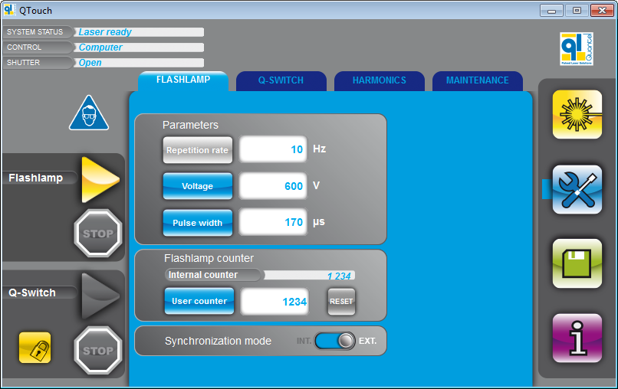

In the harmonic tab, press 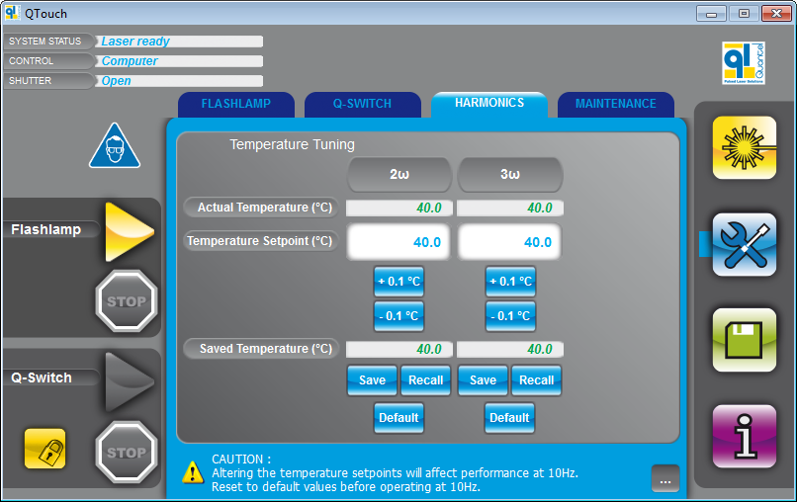button



Temperature should be close to 50°C.

If temperatures are 1°C lower or higher than 50°C, press Default T° set point.

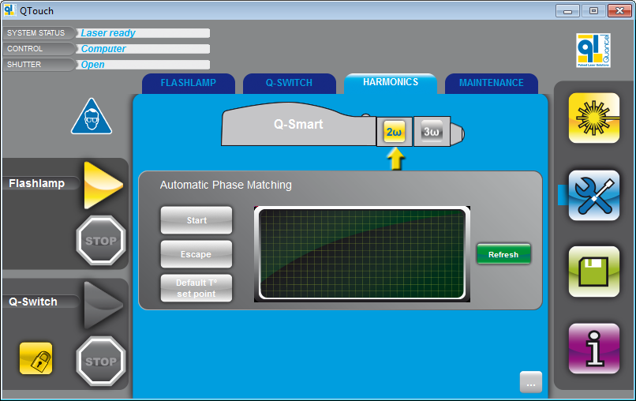

Launch APM again.

If energy is still lower, press Default T° set point. We will have to optimize energy with the crystal position.

If both crystal show abnormal temperature values, the crystal angle needs to be optimized on both HG modules (ie SHG or THG/FHG)

**SHG MODULE OPTIMIZATION**

Remove the THG or FHG, leave the SHG.

Press default T° set point.

Loosen the “locking screw” to allow crystal rotation (see red circle below).

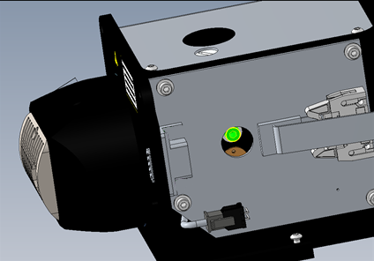

Rotate the “adjustment screw” on the top clockwise or anticlockwise to optimize the energy (red circle below).

There is not end to the screw, it will return to the same position after a certain amount of adjustment.

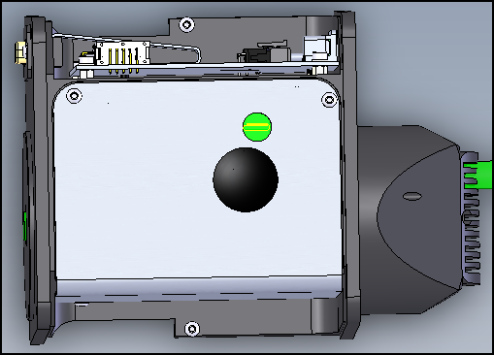

Tighten the “locking screw” and replace the cover

The SHG is now optimized for max energy.

Launch APM of the SHG module.

System should now have spec energy

**THG/FHG MODULE OPTIMIZATION**

Set the THG/FHG module on laser head (connected to the SHG module).

It is assumed that the second harmonic generator has been phase matched and delivers full specifications.

**On the Qtouch, press default T° set point.**

Loosen the “locking screw” (see red circle below) to allow crystal rotation (warning: the location of the rotation screw is different from 2w harmonic generator).



Rotate the “adjustment screw” (see red circle below) clockwise or counterclockwise to optimize the energy.

Use a “white card” to visually find the optimum point. Then adjust using the fine “adjustment screw” to achieve spec energy.



Tighten the “locking” screw and replace the cover.

Once the crystal is optimized, run a full APM 2W3W or 2W4W.